Homeroom Administrator Manual

INSTRUCTIONS FOR

ASSIGNING HOMEROOM ADMINISTRATOR

AND

MANAGING THE HOMEROOM ADMINISTRATION SYSTEM

FOR ONLINE DOE DATA COLLECTION

New Jersey Department of Education
October 2, 2013

Table of Contents

Introduction…………………………………………………………....3
Homeroom…………………………………………………………….5
Homeroom Administrator…………………………………………….6
Managing Accounts and Projects……..………………………………..7
Manage User Accounts………………………………………………...8
Create New User……………………………………………………...9
Add System to User Account……………….………………………..10
Modify User Profile…………………………………..……………….11
District Users Summary Report……………………………………...12

Introduction

The Homeroom Administration is an online management system for NJDOE Homeroom users and projects. Each district or charter school has a Homeroom Administrator account to access the Homeroom Administration System on the Homeroom website. A Homeroom Administrator is responsible for creating user accounts, and managing the user's project accessibility. A DOE Homeroom project is an online application to collect data from as well as report data to districts and schools in New Jersey with secured access. As a DOE Homeroom project is activated, it will be available for the districts and/or schools Homeroom users.
There can be only one Homeroom Administrator for each school district. The same is true for approved private schools for students with disabilities (APSSD) and charter schools. Conversely, one person can be a Homeroom Administrator for multiple districts, charter schools and APSSD. The Homeroom Administrator information is also shared with NJSMART. The information that is shared is limited to the user’s name, phone number, email and the CDS code. The Homeroom Administrator then becomes a point of contact for NJSMART.
To establish a new Homeroom Administrator or to change one a “Change the Homeroom Administrator” form must be filled out and faxed back to DOE. The form and instructions can be found at:
http://www.state.nj.us/education/data/collections/form.pdf
The new Homeroom Administrator will be informed by an official DOE email when the account has been changed and/or is ready for use.
Homeroom Administrator account information (form that was faxed to the NJDOE) only provides access to the Homeroom Administration System. To access the Homeroom project you need to have the Homeroom Administrator create a user account that is linked with the project. Once a user account is established it can be linked with multiple projects of the same security level.
Once an account for the Homeroom Administrator has been established the Homeroom Administrator can create and maintain individual user accounts using an online application. Maintaining a user’s account includes authorizing them to have access and use individual data projects. There are two security levels, district level and school level. A user account can only have access projects with the same security level so if a user needs access to projects with both level an additional user account (with a different user ID) must be created for that user. Each user should only have one account per security level.
Some of the online applications have a highly sensitive content and require complete security in accessing a system, as well as entering and changing data in a system.

It is very important that Administrator and User account passwords not be shared with any other staff. Accounts are established for the use of a specific individual; the individual’s identity will be associated with all data created or modified during a session initiated by his/her login.

There can be more than one user in a district and even in a school. All user accounts must be established by the district’s Homeroom Administrator.

- Each Homeroom Administrator can add, delete, or modify User accounts as staff members are hired, leave or change roles. This person has access to User account passwords and the ability to modify them.

- Homeroom Administrator accounts must be replaced whenever the person responsible for this role changes.

- Current accurate email address information must be maintained for all Homeroom Administrators.

To transfer Homeroom Administrator role from one individual to another the same procedure
should be followed as in creating the original Homeroom Administrator account. Any existing Homeroom Administrator account is disabled when a new one is created.

NJDOE Homeroom

http://homeroom.state.nj.us

The Homeroom Administration system is located at the top of the homeroom table.
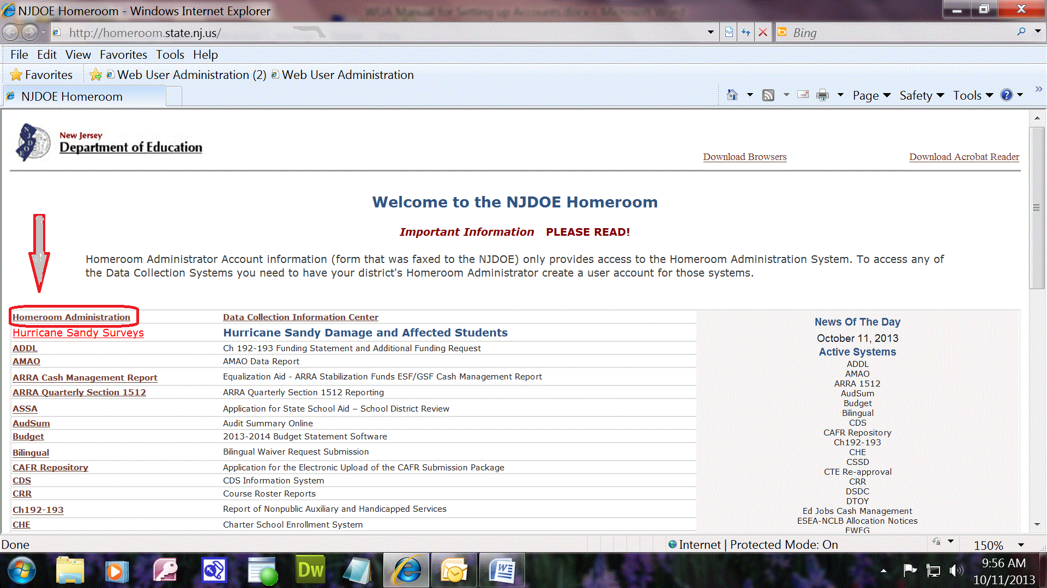

To access the Homeroom Administration system choose the “Homeroom Administration” link on the data collection home page: http://homeroom.state.nj.us/

Only Homeroom Administrators may enter this application.
Once inside the Homeroom Administration login page, please bookmark it for easy access.

Homeroom Administrator Login
Clicking the Homeroom Administration link will open up the Homeroom Administration page.
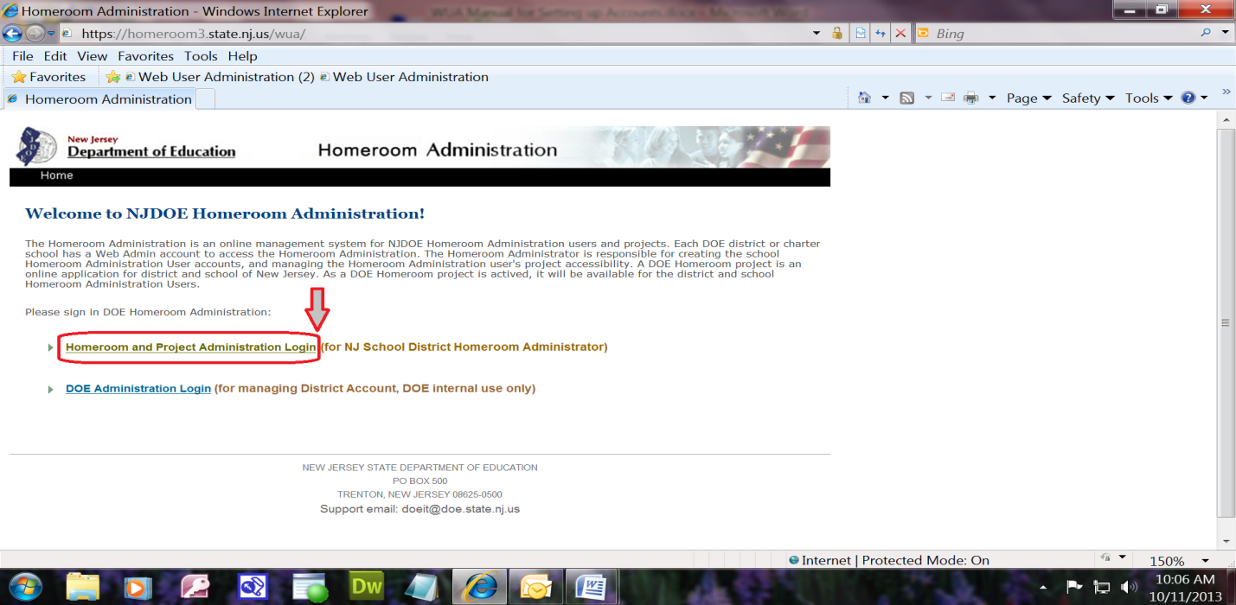
The Homeroom Administrator must click the link that says:
“Homeroom and Project Administration Login (for NJ School District Homeroom Administrator)”
The second link is for DOE use only.
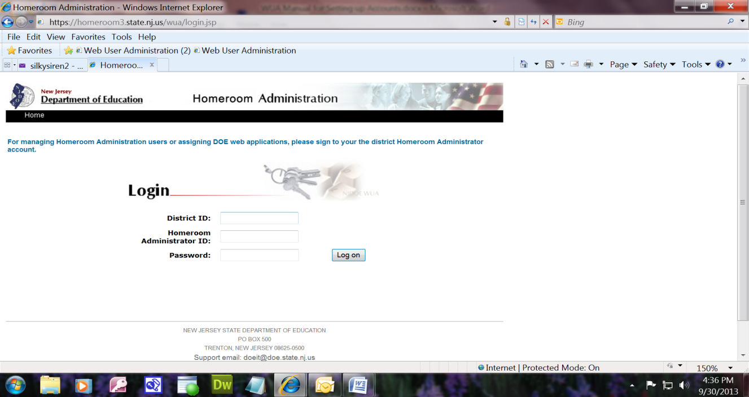

To login as the Homeroom Administrator you must enter the:
- District ID
- Homeroom Administrator ID
- Password

This action will open the Main Menu screen

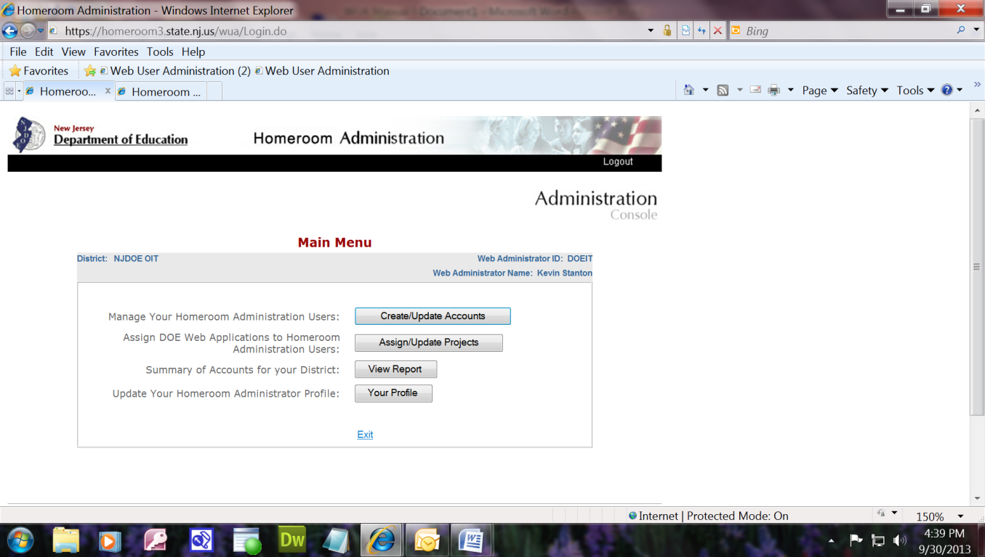
On this page the Homeroom Administrator has the options of

Create/Update Accounts
- creating, updating and deleting user accounts
Assign/Update Projects
- assigning projects to user
View Report
- viewing the summary of accounts for that district

Your Profile
- changing the Homeroom Administrator’s profile

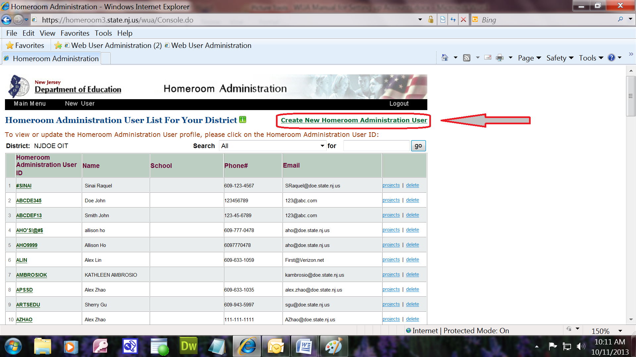

To create a new user account click on the green link at the top right corner of the screen:
“Create New Homeroom Administration User”

A blank profile form will open for you.
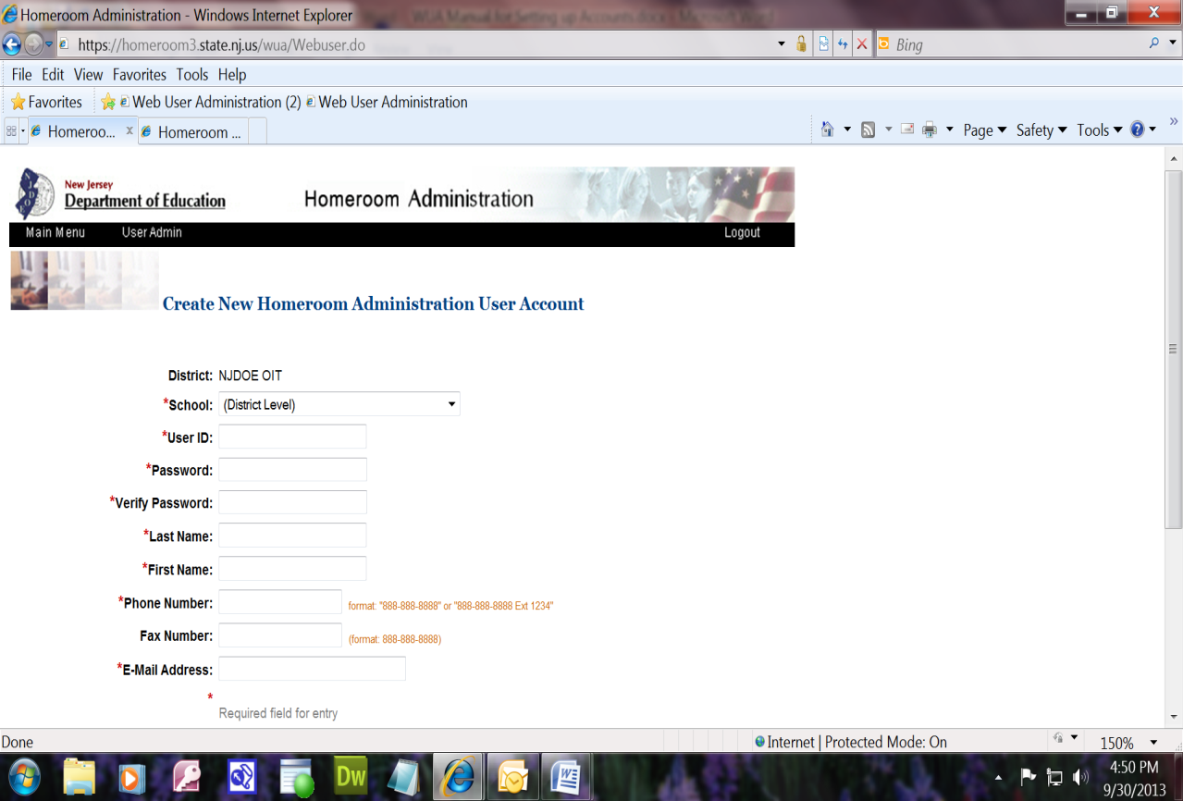

Select the security level by using the drop down arrow. If it is a district level project proceed to the next line because “District Level” is the default. If the project is school level then select the school with which the user is affiliated.

Fill in all the following information requested for a new user.
User ID, Password, First Name, Last Name, Phone Number, Email Address

- Click the “update” button to finish adding the user.
Please note that each account can be authorized as either a District- level or a School-level user. For School-level choose the school. In some cases data may be done by personnel who are authorized only for data related to a certain school.

To Authorize User for a Project you must return to the “User Table” by clicking the “Main Menu” link at the top of the page. Then click on the “Create/Update Accounts” button.

The User Administrator’s table will open for you.

 | Web User ID | Name | School | Phone# | Email
1 | #User1 | User name |  | 609-222-4455 | user@doe.state.nj.us | projects | delete

Click on the “projects” link next to the user’s data that was created.

The “Project Assignment” table will open

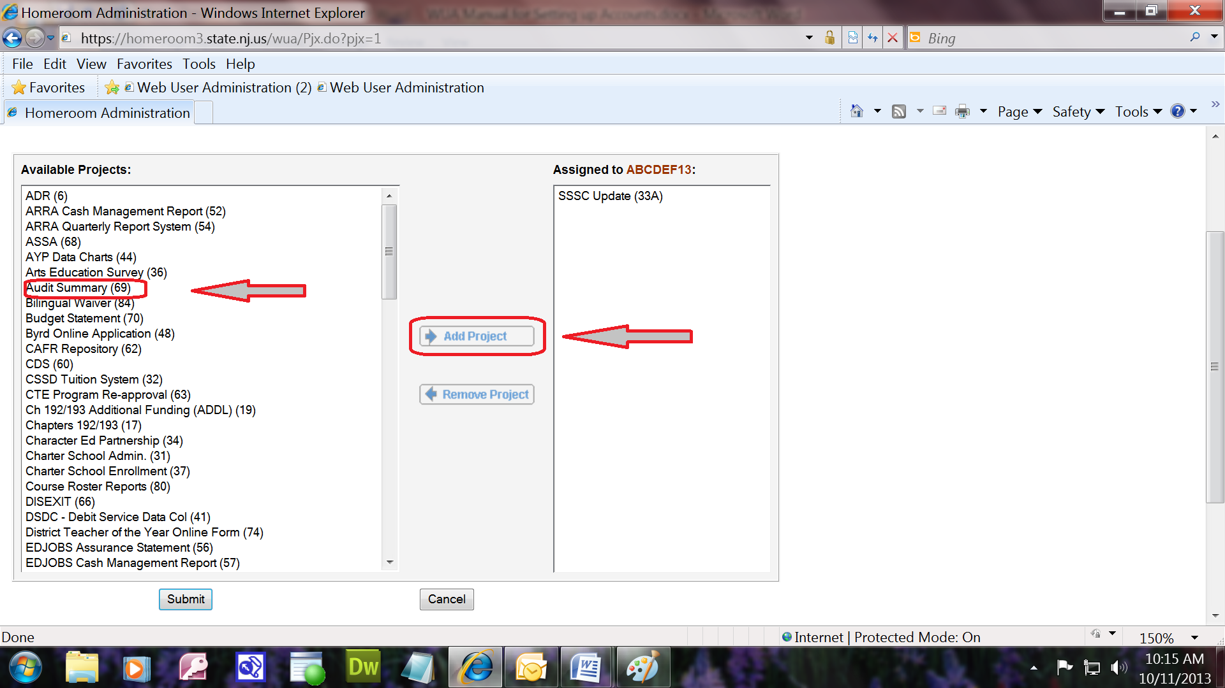

- Choose a system from the left column and move it to the right column by highlighting it and then clicking on the “Add Project” button.
- This process can be repeated as many times as necessary for the user.

- Click “Submit” button at the bottom of the page.

- Use the created user ID and password to login to all projects added to the user account.

To update or modify an existing user click on the “User ID” link in the user’s table.

 | Web User ID | Name | School | Phone# | Email
1 | #user1 | User name |  | 609-222-4455 | user@doe.state.nj.us

A profile page with the user’s information will open.

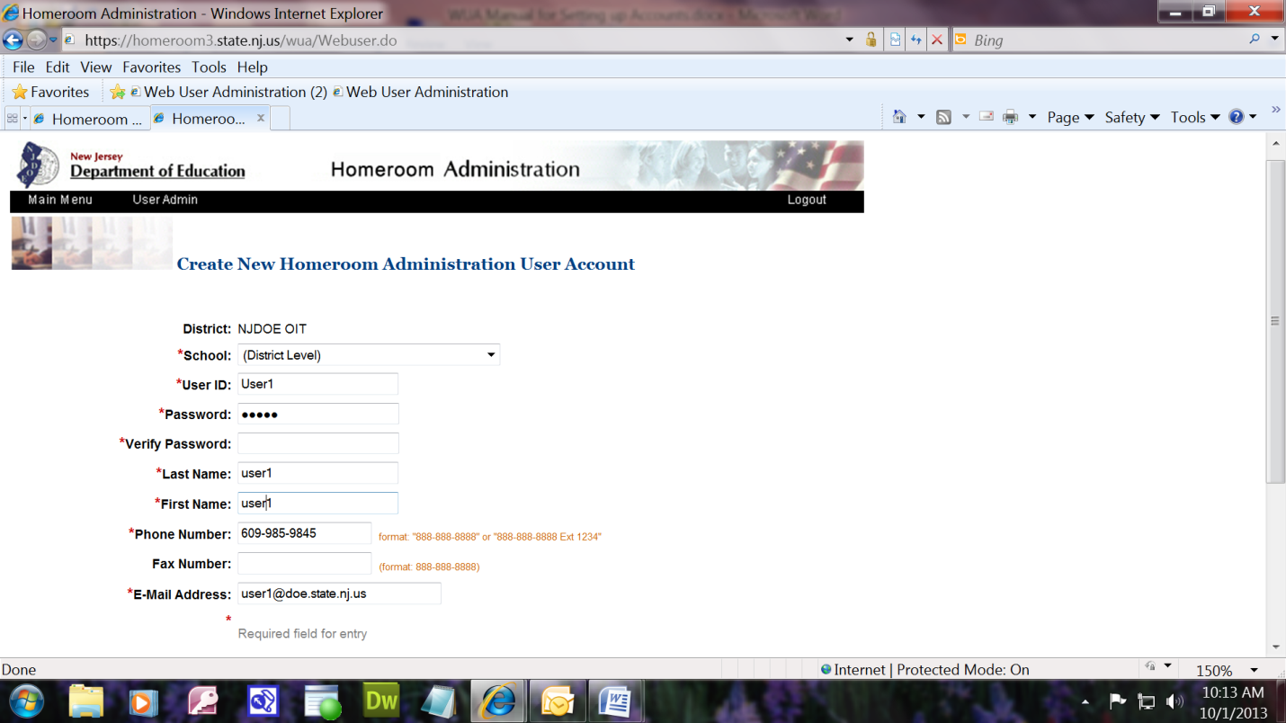

The Homeroom Administrator then can change any existing information on the page.

Summary Report

To view the summary information for all users in the district click “View Report” button on the Main Menu page.

The “Homeroom Administration User and Project Assignment Summary” screen will open up.

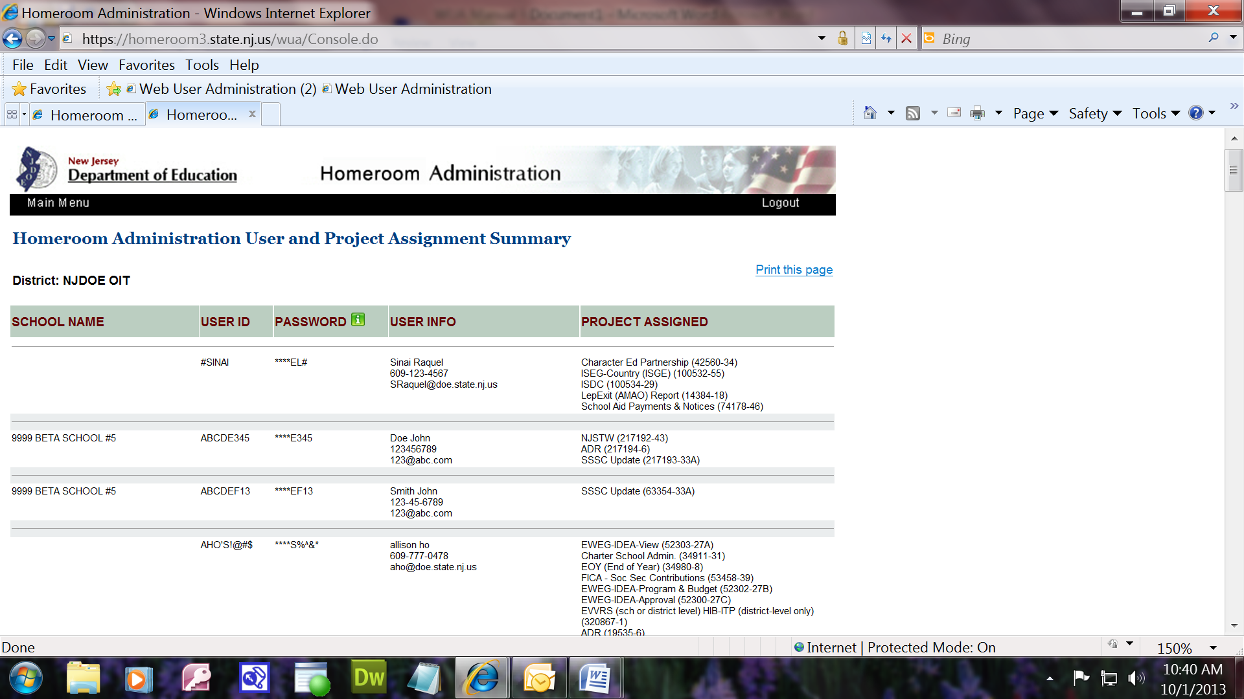

The information on this page cannot be modified from this screen. It is for viewing purposes only.

To make changes, follow the instructions on page 7.

